**SQL AGGREGATION FUNCTION**

The SQL aggregate functions — AVG, COUNT, DISTINCT, MAX, MIN, SUM all return a value computed or derived from one column’s values, after discarding any NULL values.

1)AVG - The mean average of the elements in the column

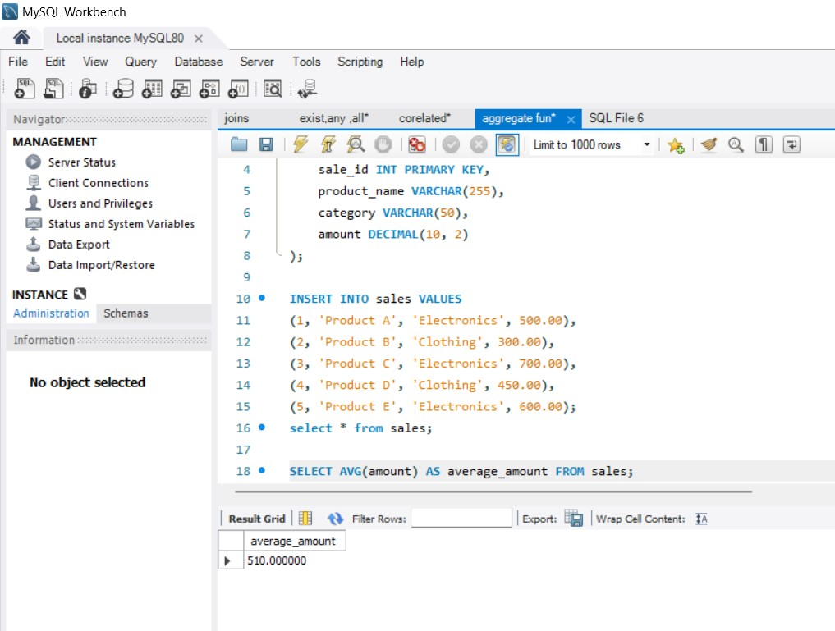

2)COUNT - The total number of elements in the column

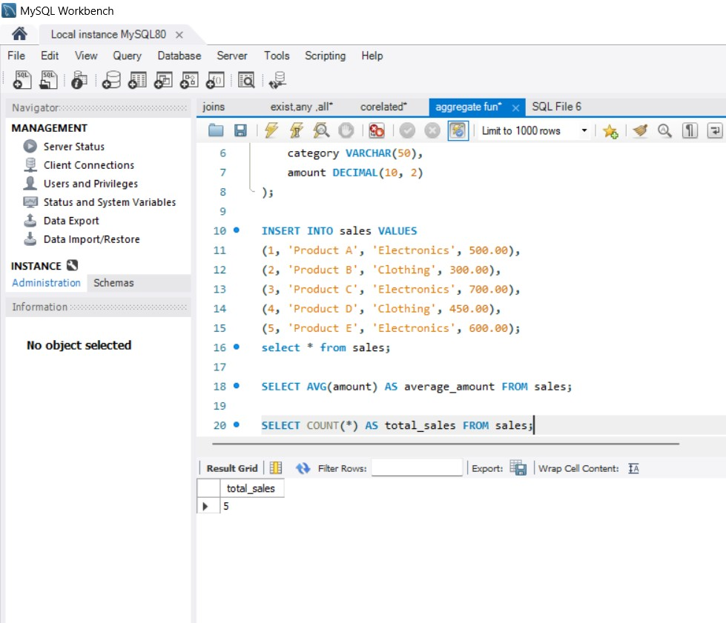

3) DISTNICT - The number of distinct values across the column

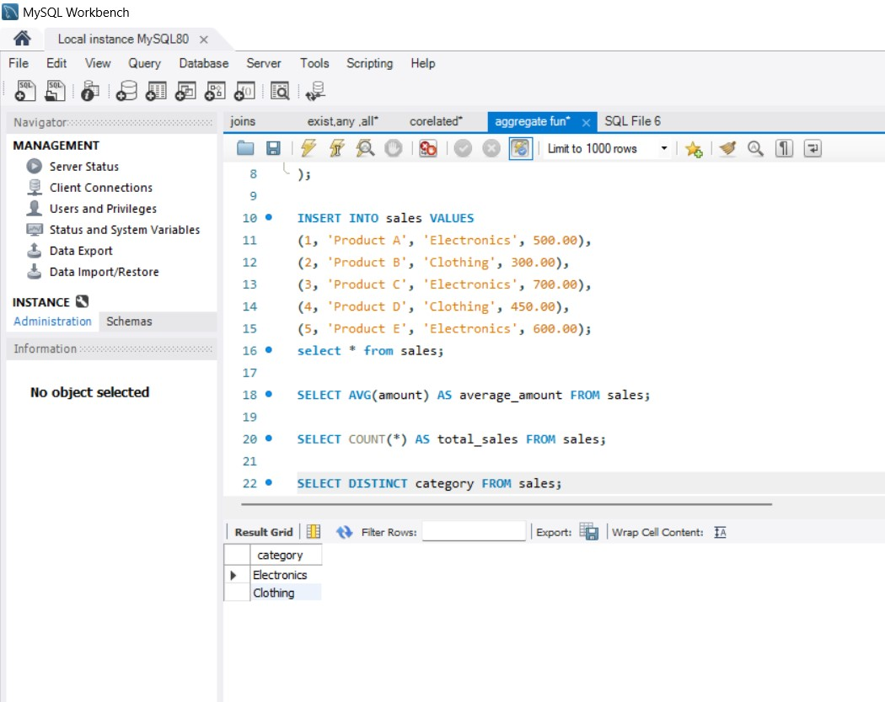

4)MIN - The smallest-value element in the column

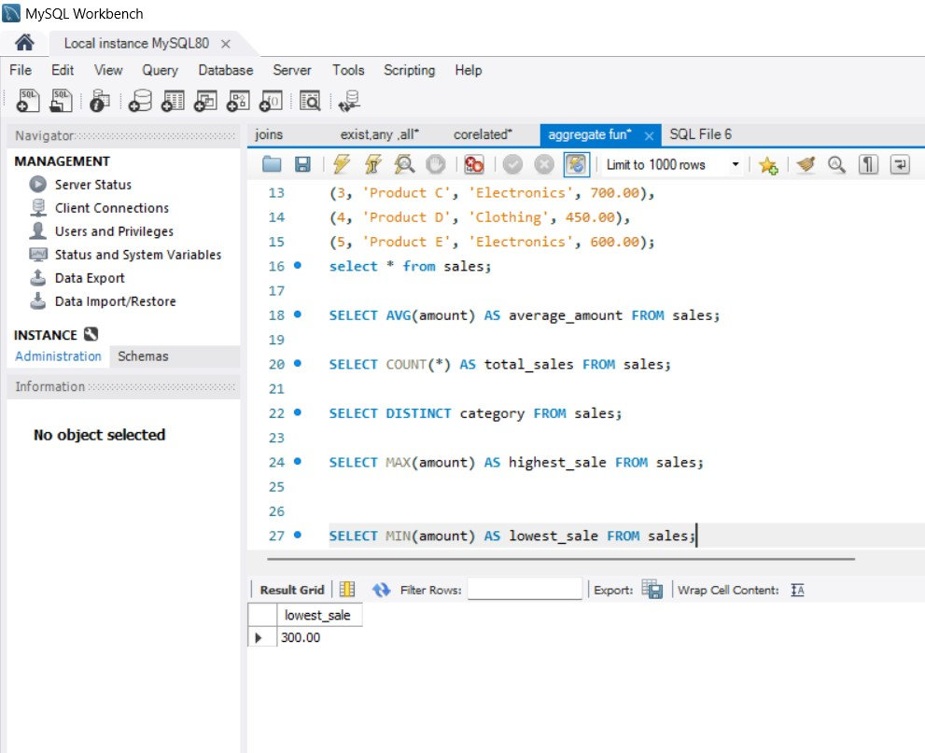

5)MAX – The largest-value element in the column

